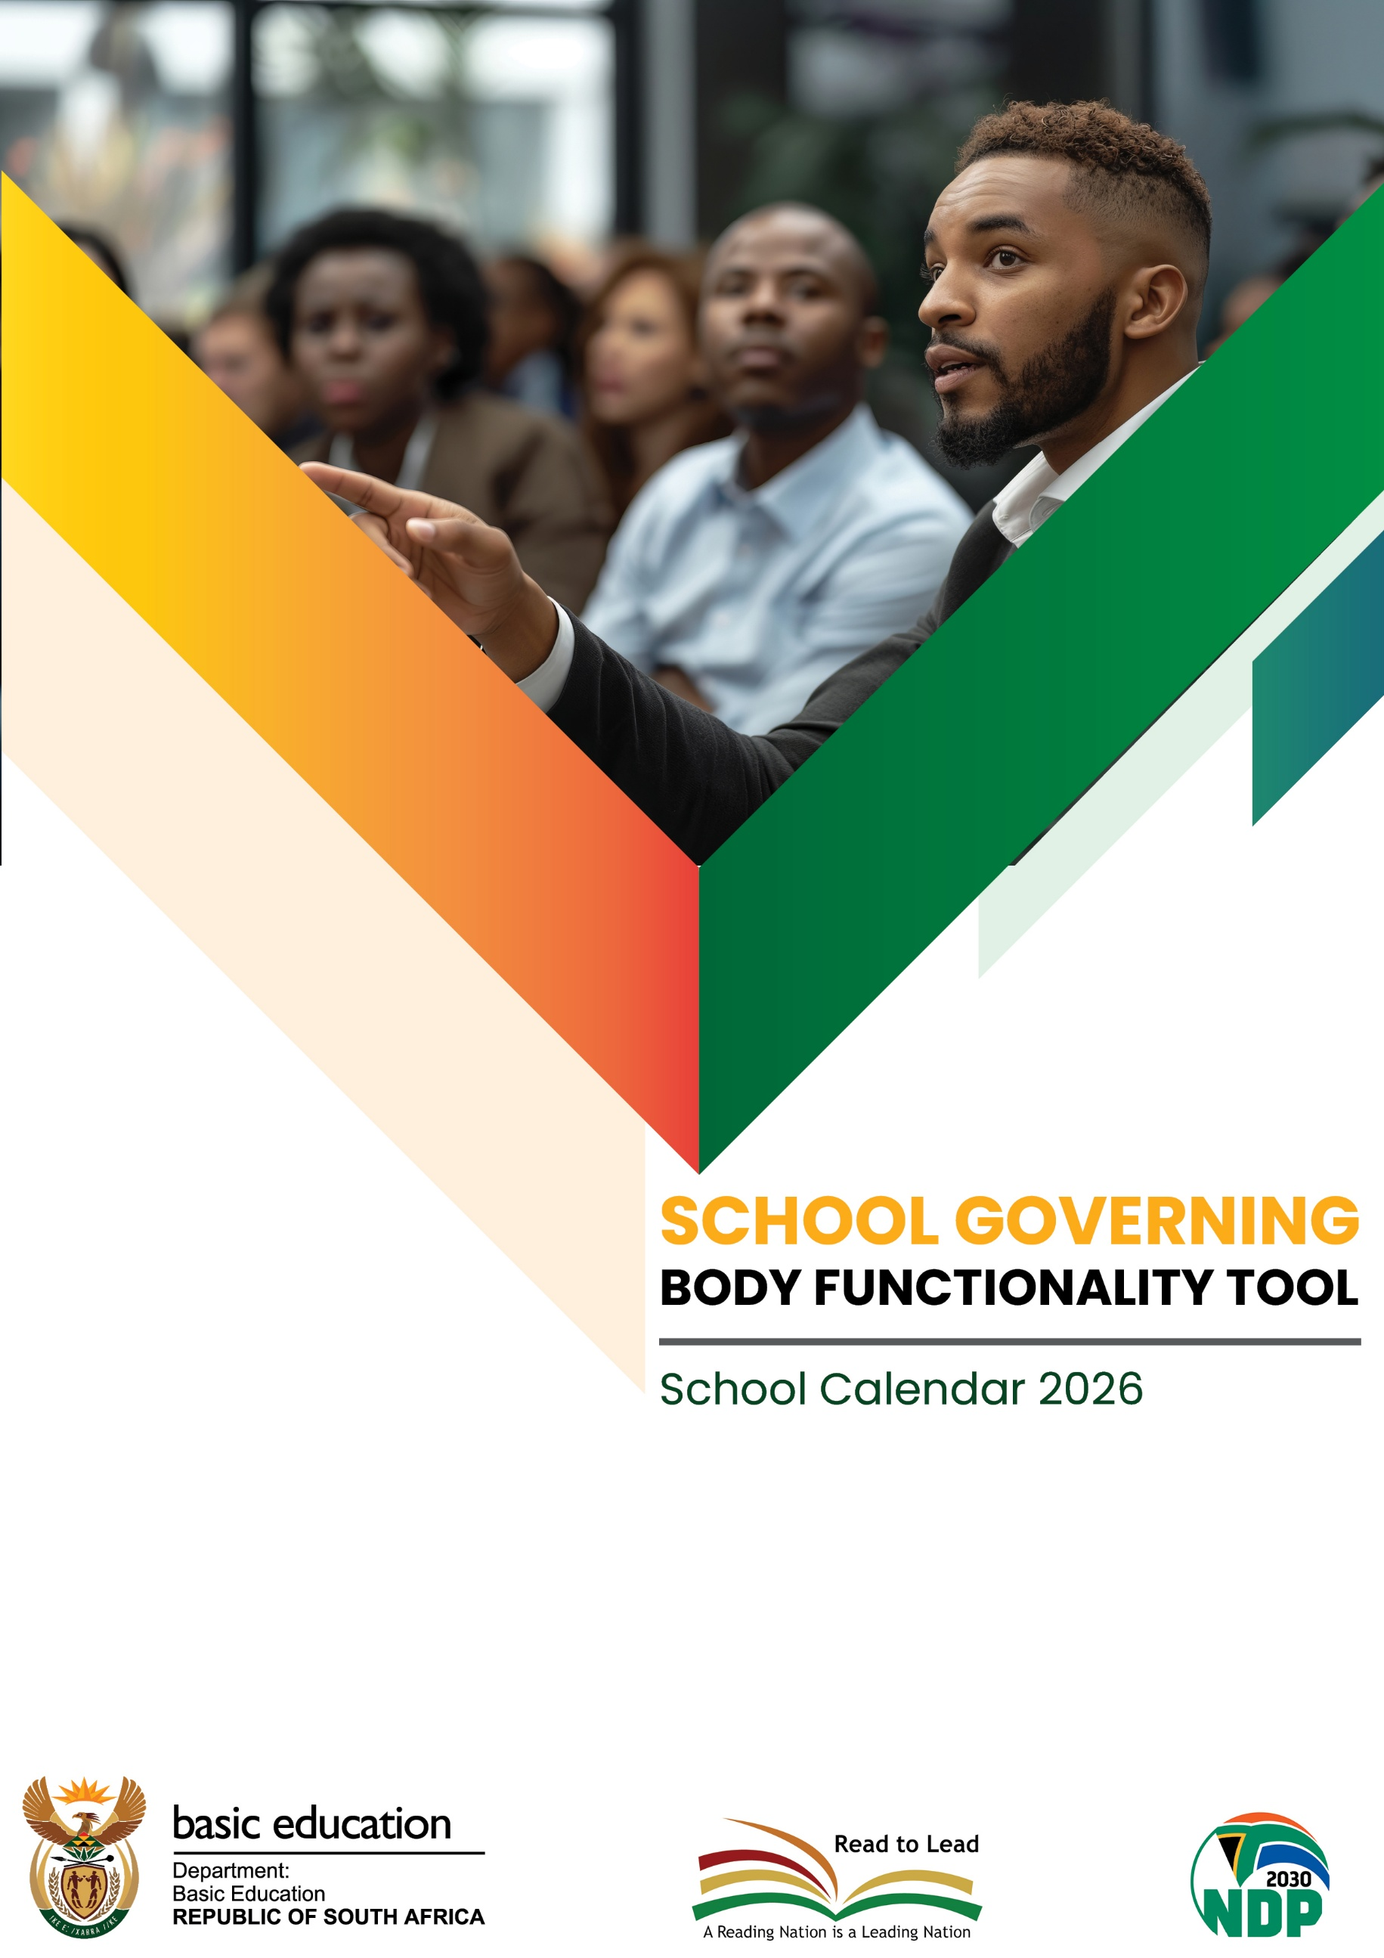

SGB Functionality Tool

- The South African School’s Act No 84 of 1996 (SASA) as amended stipulates that the governance of a school is vested in its School Governing Body (SGB).

- SASA provides for roles and responsibilities that SGBs must perform.

- The SGB Functionality Tool selects key categories from the expected roles for SGBs to self-evaluate their performance and for the Department to assess their functionality in order to determine areas of support and capacity building. The Tool further alerts of the functionality level of the SGB based on the areas in the Tool.

- Each category has 4 statements from which only ONE must be selected as they are arranged in a cascading order which the higher ranking (with evidence) presupposes that the lower criteria have been achieved. Therefore, only one block must be marked with an X per category.

- The School Principal and an SGB representative should administer the first rating and then followed by the moderation by Departmental official based on the evidence provided by the school.

- Both the school and departmental representative must sign the tool.

- The Department of Basic Education or Provincial Education Department will select a sample of schools from those rated for verification purposes.

2026

2026 SCHOOL GOVERNING BODY FUNCTIONALITY TOOL

Name of School: SIZAMULWAZI PUBLIC SCHOOL EMIS: 20600763 Province: EASTERN CAPE District: JOE GQABI

A Fee Paying: No Quintile 3 Type of School: Rural Township
Category | Rating by the school |  |  |  |  | Moderated rating  by official | Recommendation/Comment
 | Mark with an  X | Mark with an  X | Mark with an  X | Mark with an  X
1. SGB Constitution | 0  Not available | 1  Available, Consulted with all members.  (Provide evidence) | 2×  Available, Consulted with all members and in line with relevant legislation | 3  The SGB Constitution is formally submitted to the HOD within 90 days, accompanied by proof of submission and evidence that the constitution is being used to guide governance processes (e.g. referenced in meetings or governance decisions). (Provide evidence)
2. School mission statement | 0  Not available | 1  Available, Consulted with all members. | 2  Available, Consulted with all members and in line with relevant legislation.  (Provide evidence) | 3 ×  The mission statement is actively guiding school practices, is aligned to legislative and policy frameworks, and is communicated and referenced in school planning documents (e.g. SIP, policies, school communications).  (Provide evidence)
3. Admission Policy | 0  Not available | 1  Available, Consulted with all members.  (Provide evidence) | 2×  Reviewed and adopted to ensure alignment with the amended SASA provisions and provincial admission regulations | 3  The school implements the admission policy by submitting admission reports and placement challenges timeously to the District. Policy compliant with amended SASA provisions.  (Provide evidence)
4. Language Policy | 0  Not available | 1  Available, Consulted with all members.  (Provide evidence) | 2  Reviewed and adopted to ensure alignment with the amended SASA provisions and provincial language regulations | 3 ×  The school has implemented the language policy with evidence in their curriculum provisioning and admission decisions reflect the revised policy.
5. Religious Observances Policy | 0  Not available | 1  Available , consulted with all members | 2 ×  Available, consulted with all members, and in line with  relevant legislation (Provide evidence) | 3  The policy is implemented in school activities, ensuring inclusivity and compliance, with evidence such as programmes, circulars, or schedules reflecting lawful religious observances.

Category |  | Rating by the school |  |  |  | Moderated rating  by official | Recommendation/Comment
 | Mark with an  X | Mark with an  X | Mark with an  X | Mark with an  X
6. Code of Conduct for Learners | 0  Not Available | 1  Available, consulted with all members | 2  Available, Consulted with all members , and in line with relevant legislation  (Provide evidence) | 3 ×  The Code of Conduct is applied consistently, including disciplinary processes aligned to amended SASA and other legislation, with records of implementation (disciplinary hearings, learner support interventions).
7. SGB correctly constituted | 0  Not in place | 1  In place and list showing full names and contact details of all SGB  members available  (Provide evidence) | 2 ×  In place and list showing full names and contact details of all  SGB members available and all electable categories filled.  (Provide evidence) | 3  Plans in place for closing vacancies. All Secondary schools have RCL members in SGB. Each Parent linked to a learner in line with definition of a parent (Provide evidence)
8. Office‐Bearers | 0  Not in place | 1  In place | 2  In place and elected in  2026 following the correct election process and  all electable categories of office bearers filled (provide evidence) (provide minutes) | 3 ×  Office-bearers are fully constituted, trained, and have completed handover processes, with evidence of role execution (e.g. chairperson leading meetings, treasurer overseeing finances).  (Provide evidence)
9. SGB Meetings | 0  Not in place | 1  Schedule of meetings is in place  (Provide evidence) | 2  Schedule of meetings is in place, meetings conducted (Provide evidence) | 3 ×  Meetings are held as scheduled and resolutions are implemented, with action plans monitored and followed up, evidenced through progress reports and subsequent minutes.  (Provide evidence)  .
10. Finance Policy | 0  Not Available | 1  Available | 2  Available  Compliant with the amended sections and consulted with internal.  stakeholders  (Provide evidence) | 3 ×  The Finance Policy responds to the what, how and when of procurement. Compliant with the amended sections dealing with procurement, reporting mismanagement and transparency measures implemented in line with amended SASA.

Category | Rating by the school |  |  |  |  | Moderated rating  by official | Recommendation/Comment
 | Mark with an  X | Mark with an  X | Mark with an  X | Mark with an  X
11. Finance Committee | 0  Not in place | 1  In place with the treasurer as the chairperson | 2  In place and meetings held monthly (Provide  evidence) | 3×  In place, regular meetings held and school finances managed in terms of compliance with policy  and amended SASA provisions including oversight of expenditure, and reporting to the SGB.  (Provide evidence)
12. School Budget | 0  Not Available | 1  Available | 2 ×  Budget available and is prepared following.  acceptable protocols  (Provide evidence) | 3  Budget available, prepared following acceptable protocols, used to guide expenditure.  , Annual General Meeting/Budget meeting held and budget.  approved by parents, quorum requirements are met, deviations/non deviations are recorded  (Provide  evidence)
13. Financial Records | 0  Financial records are kept | 1  Financial records drawn, reported quarterly and presented to parents | 2  Annual financial statements are drawn , Tabled, Approved and Submitted to the district, audited financial statements to the HOD as legally required  (Provide evidence) | 3 ×  Financial records are properly maintained, approved, and submitted to the District, with evidence of oversight and compliance timelines being met. Quarterly reports discussed in SGB meeting.  (Provide evidence)
14. Learner Support Material | 0  Orders prepared | 1  All internal stakeholders  participated (Provide evidence) | 2  All internal stakeholders participated and  approved by the SGB.  (Provide evidence) | 3 ×  All internal stakeholders participated, approved by the  SGB and LSM processes result in orders being placed and delivered, aligned to curriculum needs, with evidence that materials are received and utilised by the school.  (Provide evidence)
15. School property, buildings, and grounds | 0  No Controls in place | 1  Controls in place | 2  Controls in place and administered by the SGB  (Provide evidence) | 3 ×  The SGB implements and monitors controls, maintains an operational maintenance plan, and ensures facilities are functional, safe, and recorded in inspections.  (Provide proof)
16. Safety Policy | 0  Not available | 1  Available and consulted with internal.  stakeholders (Provide evidence) | 2  Updated Safety Policy in line with amended legislative provisions | 3 ×  The school complies with mandatory reporting requirements, with documented reports of serious incidents submitted to relevant authorities and follow-up actions implemented.  (Provide evidence)

Total rating |  | Rating by the Principal | Rating by the Education  Official
Functionality level |  | Place x | Place x
2: 29- 48 | Meets the minimum criteria of effectiveness | 43
1: 0- 28 | Does not meet the minimum criteria of effectiveness
Total

Percentage (%) |  | 90

1. NAME OF PRINCIPAL | BOTHA M.
SIGNATURE:
Telephone/Cell no | +27 73 760 0933
DATE: | 08/04/2026
2. NAME OF SGB CHAIR | DYASI K.
SIGNATURE:
Telephone/Cell no | +27 71 328 5591
DATE: | 08/04/2026
3. NAME OF EDUCATION OFFICIAL | SIGOJO G.
SIGNATURE:
Telephone/Cell no | 0605220833
DATE:

Official School Stamp
